SERMON NOTES
DATE:____________
NAME:___________________________

What is the Good News (one sentence)?

Notes:

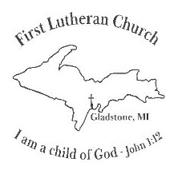
1212 Minneapolis Ave
Gladstone, MI 49837
906-428-4565
SERMON NOTES
DATE:____________
NAME:___________________________

What is the Good News (one sentence)?

Notes:

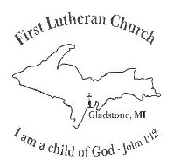
1212 Minneapolis Ave
Gladstone, MI 49837
906-428-4565

